**BANK LOAN REPORT**

1. **SUMMARY**

**KPI:**

* **Total Loan Application**

SELECT COUNT(id) AS Total_Applications FROM financial_loan;



* **MTD Loan Applications**

SELECT COUNT(id) AS Total_Applications FROM financial_loan

WHERE MONTH(issue_date) = 12



* **PMTD Loan Applications**

SELECT COUNT(id) AS Total_Applications FROM financial_loan

WHERE MONTH(issue_date) = 11



* **Total Funded Amount**

SELECT SUM(loan_amount) AS Total_Funded_Amount FROM financial_loan



* **MTD Total Funded Amount**

SELECT SUM(loan_amount) AS Total_Funded_Amount FROM financial_loan

WHERE MONTH(issue_date) = 12



* **PMTD Total Funded Amount**

SELECT SUM(loan_amount) AS Total_Funded_Amount FROM financial_loan

WHERE MONTH(issue_date) = 11



* **Total Amount Received**

SELECT SUM(total_payment) AS Total_Amount_Collected FROM financial_loan



* **MTD Total Amount Received**

SELECT SUM(total_payment) AS Total_Amount_Collected FROM financial_loan

WHERE MONTH(issue_date) = 12



* **PMTD Total Amount Received**

SELECT SUM(total_payment) AS Total_Amount_Collected FROM financial_loan

WHERE MONTH(issue_date) = 11



* **Average Interest Rate**

SELECT AVG(int_rate)*100 AS Avg_Int_Rate FROM financial_loan



* **MTD Average Interest Rate**

SELECT AVG(int_rate)*100 AS MTD_Avg_Int_Rate FROM financial_loan

WHERE MONTH(issue_date) = 12



* **PMTD Average Interest**

SELECT AVG(int_rate)*100 AS PMTD_Avg_Int_Rate FROM financial_loan

WHERE MONTH(issue_date) = 11



* **Average DTI**

SELECT AVG(dti)*100 AS Avg_DTI FROM financial_loan



* **MTD Average DTI**

SELECT AVG(dti)*100 AS MTD_Avg_DTI FROM financial_loan

WHERE MONTH(issue_date) = 12



* **PMTD Average DTI**

SELECT AVG(dti)*100 AS PMTD_Avg_DTI FROM financial_loan

WHERE MONTH(issue_date) = 11



**GOOD LOAN ISSUED**

* **Good Loan Percentage**

SELECT

(COUNT(CASE WHEN loan_status = 'Fully Paid' OR loan_status = 'Current' THEN id END) * 100.0) /

COUNT(id) AS Good_Loan_Percentage

FROM financial_loan



* **Good Loan Applications**

SELECT COUNT(id) AS Good_Loan_Applications FROM financial_loan

WHERE loan_status = 'Fully Paid' OR loan_status = 'Current'



* **Good Loan Funded Amount**

SELECT SUM(loan_amount) AS Good_Loan_Funded_amount FROM financial_loan

WHERE loan_status = 'Fully Paid' OR loan_status = 'Current'



* **Good Loan Amount Received**

SELECT SUM(total_payment) AS Good_Loan_amount_received FROM financial_loan

WHERE loan_status = 'Fully Paid' OR loan_status = 'Current'



**BAD LOAN ISSUED**

* **Bad Loan Percentage**

SELECT

(COUNT(CASE WHEN loan_status = 'Charged Off' THEN id END) * 100.0) /

COUNT(id) AS Bad_Loan_Percentage

FROM financial_loan



* **Bad Loan Applications**

SELECT COUNT(id) AS Bad_Loan_Applications FROM financial_loan

WHERE loan_status = 'Charged Off'



* **Bad Loan Funded Amount**

SELECT SUM(loan_amount) AS Bad_Loan_Funded_amount FROM financial_loan

WHERE loan_status = 'Charged Off'



* **Bad Loan Amount Received**

SELECT SUM(total_payment) AS Bad_Loan_amount_received FROM financial_loan

WHERE loan_status = 'Charged Off'



**LOAN STATUS**

SELECT loan_status, COUNT(id) AS LoanCount,

SUM(total_payment) AS Total_Amount_Received,

SUM(loan_amount) AS Total_Funded_Amount,

AVG(int_rate * 100) AS Interest_Rate,

AVG(dti * 100) AS DTI

FROM

financial_loan

GROUP BY

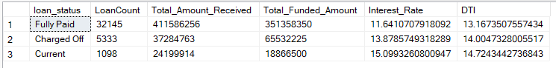 loan_status

SELECT

loan_status,

SUM(total_payment) AS MTD_Total_Amount_Received,

SUM(loan_amount) AS MTD_Total_Funded_Amount

FROM financial_loan

WHERE MONTH(issue_date) = 12

GROUP BY loan_status

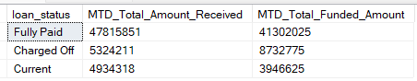

1. **OVERVIEW**

**MONTH**

SELECT

MONTH(issue_date) AS Month_Munber,

DATENAME(MONTH, issue_date) AS Month_name,

COUNT(id) AS Total_Loan_Applications,

SUM(loan_amount) AS Total_Funded_Amount,

SUM(total_payment) AS Total_Amount_Received

FROM financial_loan

GROUP BY MONTH(issue_date), DATENAME(MONTH, issue_date)

ORDER BY MONTH(issue_date)

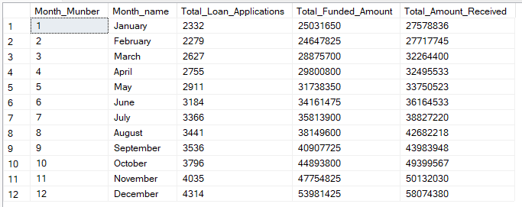

**STATE**

SELECT address_state AS State,

COUNT(id) AS Total_Loan_Applications,

SUM(loan_amount) AS Total_Funded_Amount,

SUM(total_payment) AS Total_Amount_Received

FROM financial_loan

GROUP BY address_state

ORDER BY address_state

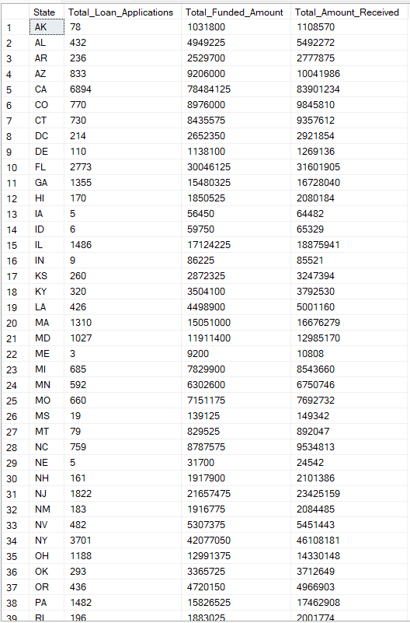

**TERM**

SELECT term AS Term,

COUNT(id) AS Total_Loan_Applications,

SUM(loan_amount) AS Total_Funded_Amount,

SUM(total_payment) AS Total_Amount_Received

FROM financial_loan

GROUP BY term

ORDER BY term

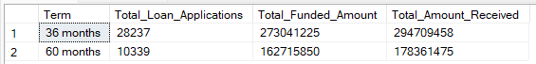

**EMPOLYEE LENGTH**

SELECT emp_length AS Employee_Length,

COUNT(id) AS Total_Loan_Applications,

SUM(loan_amount) AS Total_Funded_Amount,

SUM(total_payment) AS Total_Amount_Received

FROM financial_loan

GROUP BY emp_length

ORDER BY emp_length

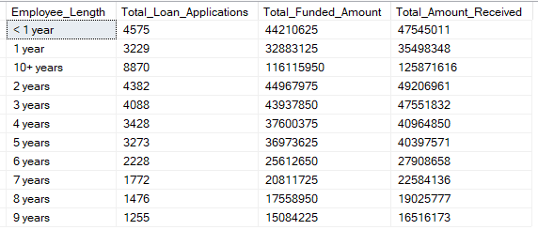

**PURPOSE**SELECT purpose AS PURPOSE,

COUNT(id) AS Total_Loan_Applications,

SUM(loan_amount) AS Total_Funded_Amount,

SUM(total_payment) AS Total_Amount_Received

FROM financial_loan

GROUP BY purpose

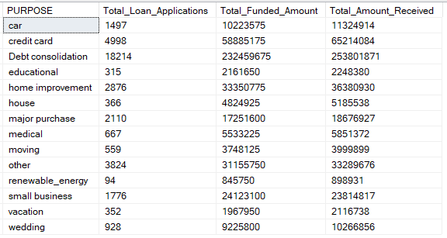ORDER BY purpose

**HOME OWNERSHIP**

SELECT home_ownership AS Home_Ownership,

COUNT(id) AS Total_Loan_Applications,

SUM(loan_amount) AS Total_Funded_Amount,

SUM(total_payment) AS Total_Amount_Received

FROM financial_loan

GROUP BY home_ownership

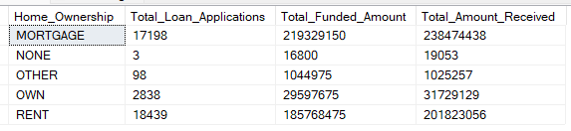ORDER BY home_ownership